WELLNESS &  PREVENTION  SERVICES |  |  |  |  |  | DECEMBER NEWSLETTER
 |  |  |  |  |  | FALL 2018
 |  |  |  |  | More animals in sweaters

World AIDS Awareness

December first is World AIDS Day. This is an internationally recognized day dedicated to raising awareness of the AIDS pandemic caused by the spread of HIV infection and mourning those who have died of the disease. Government and health officials, non-governmental organizations, and individuals around the world observe the day, often with education on AIDS prevention and control.
World AIDS Day is one of the eight official global public health campaigns marked by the World Health Organization (WHO), along with World Health Day, World Blood Donor Day, World Immunization Week, World Tuberculosis Day, World No Tobacco Day, World Malaria Day and World Hepatitis Day. Did you know that there is over the counter testing available for HIV? Read below to find out more!
 |  |  |  |  | 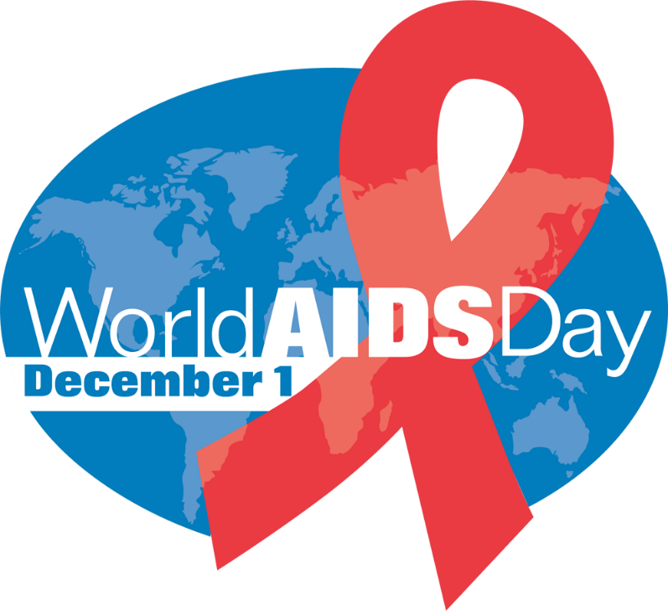
Fast  Fact |  | In 2012 the U.S. Food and Drug Administration announced that it had approved the first, over-the-counter (OTC) sale of home HIV test kits that do not require sending sample to a lab. This is an oral swab test. The FDA guidelines state that anyone 17 years of age can purchase a kit without medical training or requirement to disclose results to local medical authorities. Neither a doctor's prescription nor a parent's permission is required. How cool is that?

Fitness Ideas  There is no debating that it’s cold outside. And that it will STAY cold outside for quite some time. Here are some ways to keep up that fitness while staying indoors!  - Ride It Out: Try a spin class at your local wellness center!  - Lap It Up: Never too early for a swimsuit—as long as you’re in an indoor pool!  - Hit A Wall: Indoor rock climbing is a great way to ramp up that cardio!  - Slow Your Roll: Tai Chi is a low-impact martial arts exercise that improves cardiovascular strength!  - Shoot Some Hoops: Indoor Basketball. Grab some friends for 3 on 3.  Need I say more? Get out there! |  |  |  | Peer Educator Updates  Throughout this semester, our peer educator groups have done a phenomenal job! As of the end of November, the Wellness Educators for Change, Advocacy, and student Needs have completed 31 trainings; Red Flag Educators have completed 12; and over *400* requests have been filled by our Condom Fairy!  Do you know a student who would be a great fit for our Wellness Educators? Have them apply to be a WE CAN member! Applications will be live on AppSync during the Spring 2019 semester. Check back for more details after the break! |  |  |  | Student Highlight  Three of our peer educators are graduating this month! We would like to highlight Ashley Wainright, Katina Leger, & Tori Tensi (below). These three members have been fundamental to the success of WE CAN and the Red Flag Educators. We will miss you all!
December Events
WINTER BREAK!
 | Website: |  |  |  | Contact: |  |  |  | Email:
 | wellness.appstate.edu |  |  |  | 828.262.3148 |  |  |  | prevention@appstate.edu
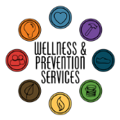
What’s happening
in Wellness?

